

AHEC Virtual Cessation Group
Participant Instructions

Thank you for registering to attend a Tobacco Cessation Virtual Group using the ZOOM platform. Please follow these instructions to access your class.
Zoom Instructions
- The first thing you will need to do in order to access a virtual cessation group is to download the Zoom program.
  - If you are planning to join from a mobile device (Android smartphone/tablet, Apple iPhone/iPad), you will want to search for Zoom in the App/Play Store and download.
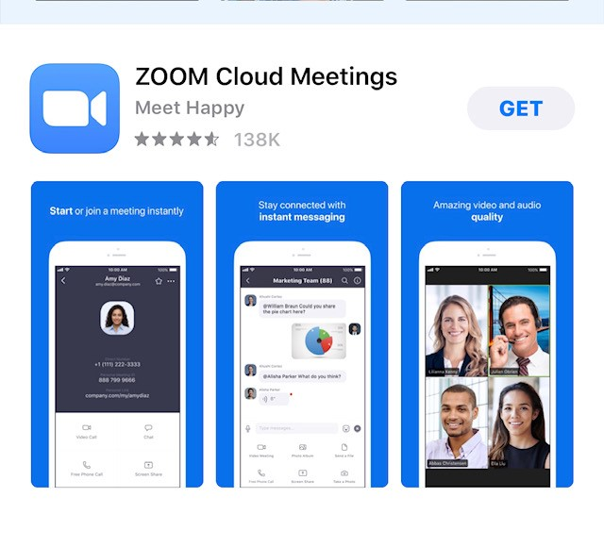

Revised 4/2/2020

  - If you are planning to join via computer, you will need to download a small application file. This process is easy to complete on all commonly used browsers. Go to https://zoom.us/download and from the Download Center, click on the Download button under “Zoom Client for Meetings”.

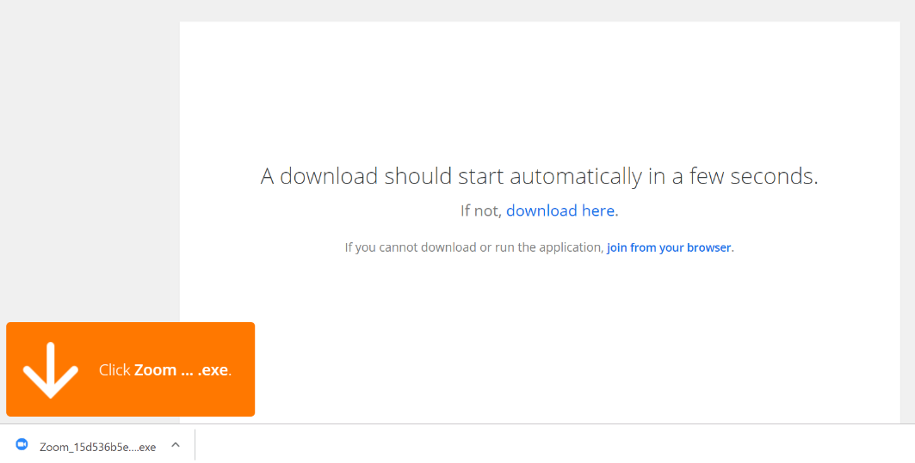

- This example shows what it looks like to download Zoom using Google Chrome.
- Internet Explorer or Edge - select “Run” at the bottom of the screen. If using
- Firefox or Safari - select “Save File” and then go to your downloads folder and double click on Zoominstaller.exe. When the dialogue box pops up, click on “Yes.”

- Once you have signed up for a class, you will receive an email with a link. Click the link to register in advance of the class. If you cannot click the link, try copying and pasting the link into your browser.
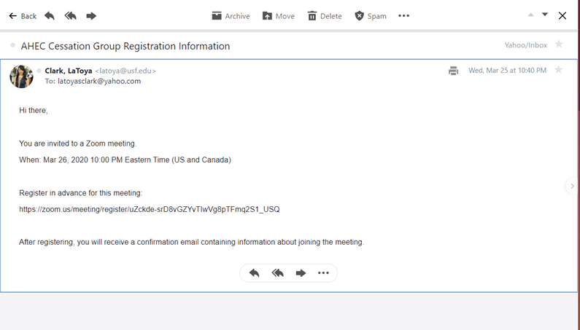

- After clicking on the link in the email above, you will see the registration view below. Please enter your full first and last name and email address. This is required for receipt of the nicotine replacement products. Click register to submit your registration.
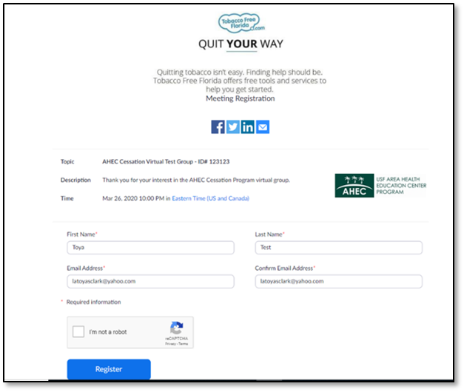

- After completing the registration page, you will see the page below and receive a confirmation e-mail that will include a Zoom link to access the class.
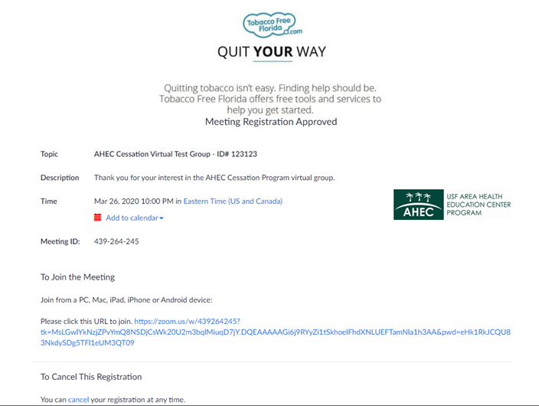

- At the time of the class, click on the Zoom link or go to https://zoom.us and enter the meeting ID in the appropriate field (the meeting ID will be a 9 or 10 digit number. You may be asked to enter a password in order to access the class.
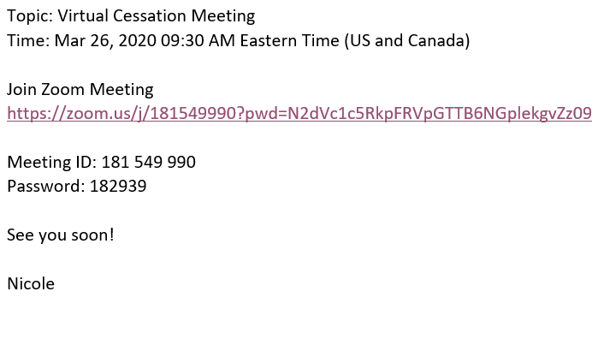

- If you are accessing audio via telephone, you will need the teleconferencing number provided in the invite. Please use the toll free number listed for US (New York) to call in to the class.
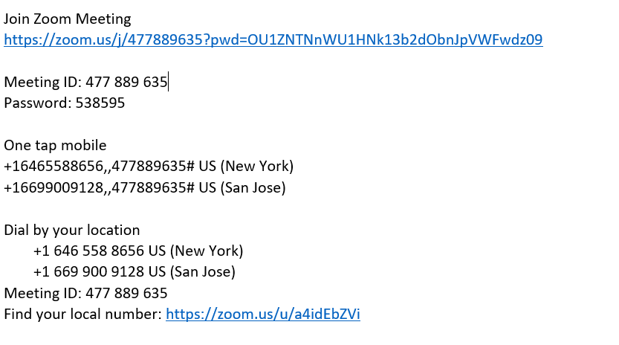

- You may be asked to enter a display name as an identifier. Please enter your name and then select if you would like to connect audio and/or video and click Join.
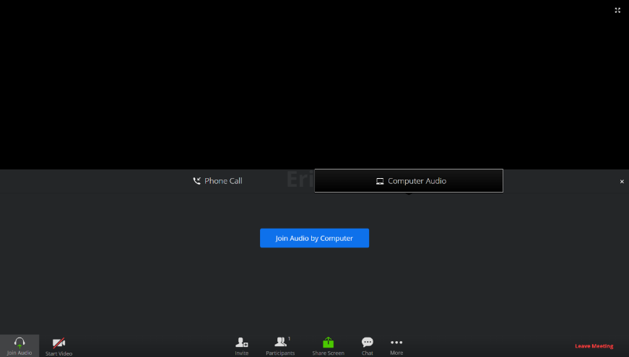

- You will see a video preview requesting if you would like to join with video or without video. The video will display what your camera sees in the preview pane. Choose if you would like to join the class with video or without video.
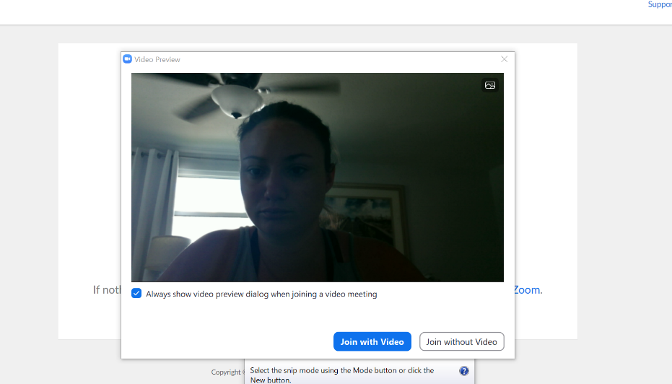

YOU

Attendee Controls

When you join a Zoom meeting hosted by another user, you are considered an attendee. The controls will appear at the bottom of your screen. This screenshot shows what the participant controls will look like on a computer. If connecting from a mobile device, the same controls are available however, they will look slightly different.

Attendees have access to these features:
- Mute/Unmute: Mute and unmutes your microphone.
- Audio Controls (click the ^ arrow next to Mute / Unmute): Allows you to change the microphone and speaker that Zoom is currently using on your computer, leave computer audio, and access the full audio settings.
- Start Video / Stop Video: Turns your camera on or off.
- Video Controls (click the ^ arrow next to Start Video / Stop Video): Change cameras if you have multiple cameras, select a virtual background (if enabled), or access your full video settings.
- Participants: See who's currently in the meeting. The Participants list also gives you access to these options:
- Chat: Access the chat window to chat with the participants.
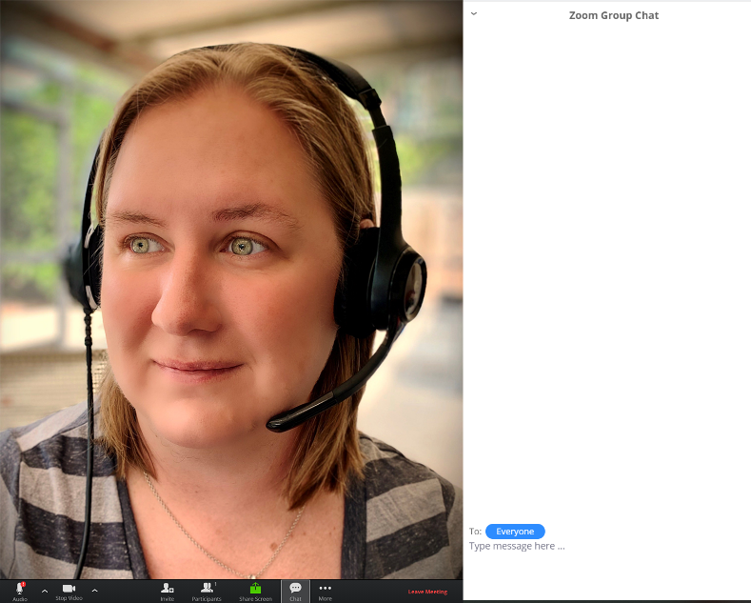
INSTRUCTOR

- Non-verbal feedback icons (if enabled by the host): Places an icon beside your name to quickly notify the host. For example, Raise Hand places the raise hand icon beside your name and simulates a hand raise.

- Leave Meeting: Leave the meeting while it continues for the other participants. Only the host can end the meeting.

General Reminders

- Remember to mute your microphone when you’re not speaking. You can mute yourself by clicking on the microphone icon in the bottom left corner of the screen.
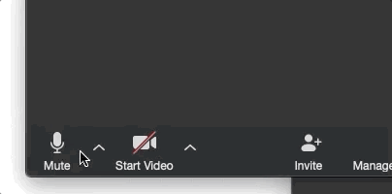

- Adjust your camera accordingly.

  - Make sure your face is visible.
  - Use front lighting instead of backlighting to prevent appearing as a shadow.

- Zoom has two viewing options that can be toggled (changed) in the top right corner.

  - Speaker view allows you to view only the person that’s speaking.
  - Gallery view allows you to see all participants in the meeting.
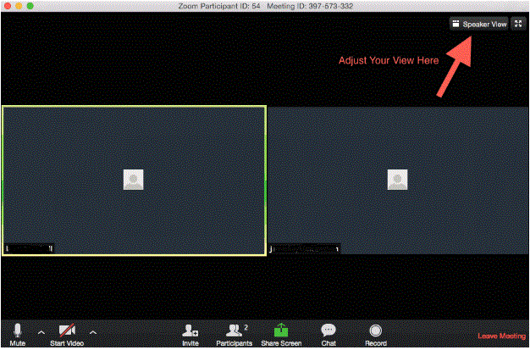

Virtual Cessation Class Group Expectations

The following is a list of expectations for participants during virtual cessation groups.

- Participants will join the class in a private location of their home in order to minimize background distractions (children, other family members, pets, etc.).
- Please have paper and writing instrument ready to complete activities.
- Participants will not be permitted to smoke, vape or use smokeless tobacco during the class.
- Participants must wear appropriate clothing.
- Participants must keep their microphones/phones on mute unless they are called on to share or ask a question. This helps to eliminate background noise that could interfere with others hearing the instructor.
- Phone calls and texting on a cell phone during class is for emergencies only.
- Participants will be respectful of the other participants during class.

* Participants who do not meet group expectations may be muted or taken off the call by the instructor.

