

AHEC Virtual Cessation Groups
Zoom Facilitator Guide

How to access Zoom

Zoom Web Portal

www.zoom.us

Download Zoom app to desktop
- zoom.us/download
- download “Zoom Client for Meetings”

How to use Zoom

From your profile page you can access Zoom Live Training Webinars by clicking the Attend Live Training link. In addition to the live trainings, the Zoom help center (meetings and webinars) have many tutorials for learning how to use Zoom.
- For experienced users, complete the “Getting Started with Zoom Meetings” 30 minute webinar.
- For beginners, complete the “Zoom Meeting” 60 minute webinar

Scheduling a Meeting
- Open your Zoom client and sign in to Zoom.
- Click on the Schedule icon.
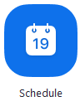
This will open the scheduler window.
- Select your meeting settings. Note that some of these options might not be available if they were disabled and locked to the off position at the account or group level.

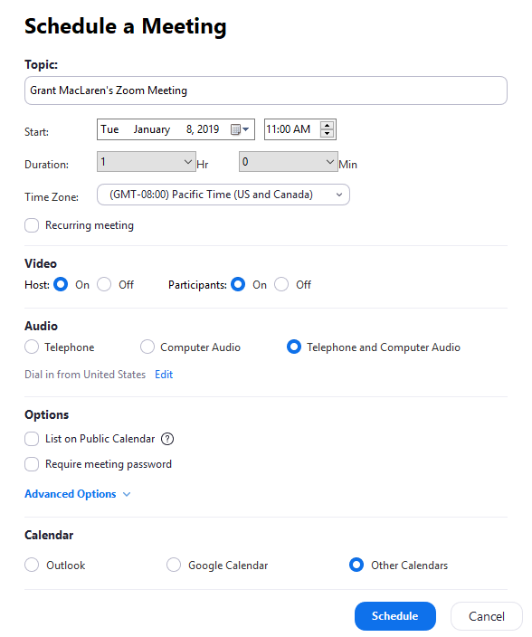
  - Topic: Tobacco Free Florida AHEC Cessation Virtual Class, TFFACT Course ID#
  - Start: Select a date and time for your meeting. You can start your meeting at any time before the scheduled time.
  - Duration: Tools to Quit (2hrs). This is only for scheduling purposes. The meeting will not end after this length of time.
  - Time Zone: By default, Zoom will use your computer's time zone. Click the drop-down menu to select a different time zone.
  - Registration Required for all Tobacco Free Florida AHEC Cessation Virtual Classes: Click this box
  - Video Host: Choose Host video to be ON.
    - Participant: Choose participants video to be ON.
  - Audio: Choose Telephone and Computer Audio
  - Advanced Options: Click on the arrow to view additional meeting options.
    - Alternative hosts or co-host: Enter the email address of another Zoom user who is licensed, on your account to allow them co-host.
  - Calendar: Select a calendar service to add the meeting to and send out invites to participants.
  - Click Schedule to finish, and open the selected calendar service to add the meeting.
  - PASSWORDS are required for ALL Virtual Meetings for Tobacco Free Florida AHEC Classes.

Meeting Templates

When you schedule a meeting, you can save the settings for that meeting as a template for scheduling future meetings. The template includes settings like enabling join before host, automatic recording, and alternative hosts. For recurring meetings, you also have the option to save the recurrence schedule as part of the template.

After you save a meeting as a template, you can select that template when you want to create a meeting with similar settings. You can select from up to 40 saved meeting templates.

Creating a meeting template

To create a meeting template, you configure and save a meeting with the settings you need, then save that meeting as a template. To create a meeting template:
- Sign in to Zoom web portal.
- In the navigation menu, click Meetings.
- Click Schedule a New Meeting.
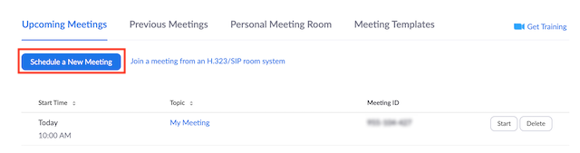
- Change the settings that you would like to apply to the template.
Note: All settings made while scheduling the meeting will be applied to the meeting template. This includes polling.
- Click Save.
- Click Save as a Meeting Template.
- Specify the Template Name, then click Save as Template.
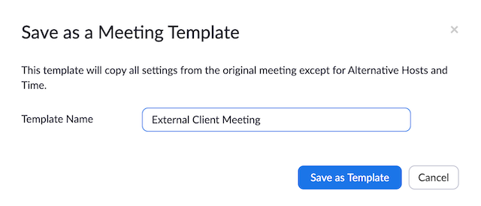

Scheduling a meeting from a template

After you have created one or more meeting templates, you can schedule a new meeting that includes all of the settings from that template. Note that the new meeting does not include the dates. To schedule a meeting from an existing template:
- Sign in to Zoom web portal.
- Click Meetings.
- Click Schedule a New Meeting.
- Choose a previously saved template from Use a template menu.
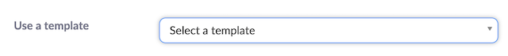Basic and advanced settings from the template are copied into the newly created meeting.
- Update the meeting name and description (if needed), and update the date/time information or recurrence information if you saved this in the template.
- Change any other settings, then click Save.
Note: If you have saved one or more meeting templates, you can view or delete them from the Meeting Templates tab. You can save up to 40 meeting templates.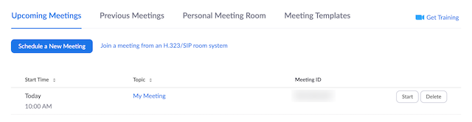

How do I invite attendees?

You can find the invitation for a scheduled in the Zoom desktop client, Zoom mobile app, or on the web. You can copy the invitation and send it out to your attendees. You can share it anywhere that text can be pasted, but the most common methods to share the full invitation are via email or by adding it to a calendar invitation.

To see all options on how to invite attendees, see How Do I Invite Others to Join a Meeting?
- Open the Zoom client and sign in to Zoom.
- Click Meetings.
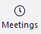
- In the Upcoming tab, select the meeting that you need the invitation for.
- Click Copy Invitation.
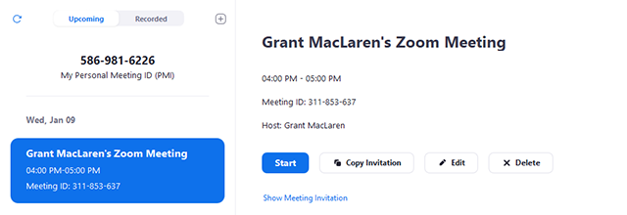

The meeting invitation will now be copied to your clipboard and you can copy and paste into an email invitation in Outlook.

How do I Start a Scheduled Meeting as the Host?
- In the Zoom client, click Meetings.

- Under the Upcoming tab, select the meeting you want to start. Additional options will appear.
- Click Start.

Controls for hosts and co-hosts

With meetings, hosts and co-hosts can control the following features:
- Mute participants
- Request that a participant unmute
- Stop a participant's video
- Request that a participant starts their video
- Prevent participants from screen sharing
- Rename a participant
- Put a participant on hold if enabled
- Choose to play an enter or exit chime
- Lock the meeting to prevent anyone new from joining
- Place participants in waiting room or admit/remove participants from the waiting room (waiting room can only be enabled by the host)

Only hosts have access to these features:
- Give a participant the ability to record locally
- Make a participant host or co-host
- Enable waiting room

Controls for managing participants
- Click Manage Participants in the host controls to display the participants list:

- Click the drop-down menu located at the top-left corner to close the participants list or click Pop Out to separate the participants list from the meeting window:
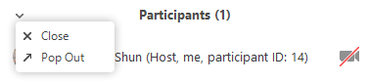
- Hover over a participant and click More for these options:
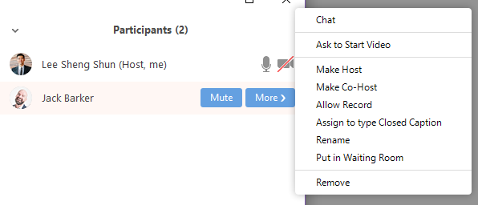
- Chat: Open the chat window to send messages directly to the panelist.
- Stop Video: Stop the participant's video stream so they are unable to start their video. If the participant hasn't started their video, you will see the Ask to Start Video option.
- Make Host (only available to the host): Assign the attendee to be the host. There can only be one host.
- Make Co-Host (only available to the host): Assign the attendee to be a co-host. You can have an unlimited number of co-hosts.
- Allow Record (only available to the host): Allow the attendee to start or stop a local recording of the meeting. Attendees do not have access to start a cloud recording.
- Assign to type Closed Caption (only available to the host): Assign the attendee to type closed caption during the meeting.
- Rename: Change the attendee name that is displayed to other participants. This change only applies to the current meeting.

Note: To change your own name that is displayed, hover over your name in the participants list and click Rename. You can permanently change your name in your profile.
- Put in Waiting Room: Place the attendee in a virtual waiting room while you prepare for the meeting. The host must enable waiting room for this option to appear.
- Put On Hold: If the waiting room is not enabled, you'll see this option to place an attendee on hold.
- Remove: Dismiss a participant from the meeting. They won't be able to rejoin unless you allow participants to rejoin.

You will also have access to enable or disable these options at the bottom of the participants list:

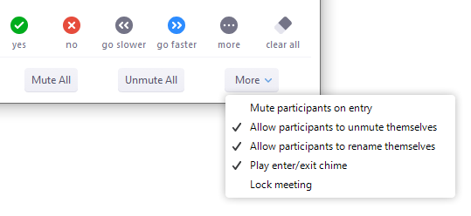
- Mute All / Unmute All: Mute or unmute all participants currently in the meeting.
- Mute participants on entry: Automatically mute participants as they join the meeting.
- Allow participants to unmute themselves: Participants can unmute themselves if they want to speak to others in the meeting.
- Allow participants to rename themselves: Check the box if you want to disable allowing participants to rename themselves.
- Play enter/exit Chime: Play a sound when participants join and leave the meeting
- Lock meeting: Don't allow other participants to join the meeting in progress.
- Merge to meeting window: Merge the participants list with the main meeting window. This option is only available if you separated the participants list from the main meeting window.

To prevent participants from screen sharing:
- In the host controls, click the arrow next to Share Screen and click Advanced Sharing Options.
- Under Who can share? Choose Only Host.
- Close the window.

Enabling Waiting Room - Facilitators can use their own discretion for virtual classes if they want to use the waiting room function.

Individual meeting

Before you can enable Waiting Room for an individual meeting, you must enable it in your meeting settings.
- Sign in to the Zoom web portal.
- Click meetings.
- Click a meeting topic to edit it or schedule a new meeting.
- Under Meeting Options, check Enable Waiting Room.
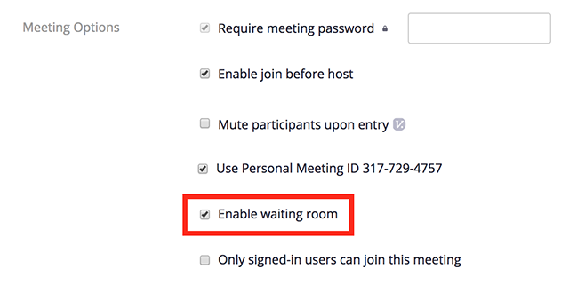
- Click Save.

Using Waiting Room

Enabling or disabling Waiting Room during a meeting
- As the meeting host, click Manage Participants.
- Click More at the bottom of the participants' window and choose Put Attendee in Waiting Room on Entry to enable or disable the feature.
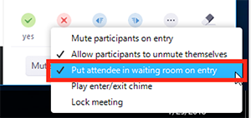

Admitting participants during a meeting
- As the meeting host, click Manage Participants.
- Click Admit to have the participant join the meeting.
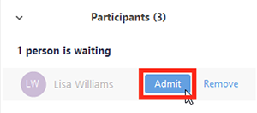

Admit all participants from the Waiting Room
- As the meeting host, click Manage Participants.
- Click Admit all.
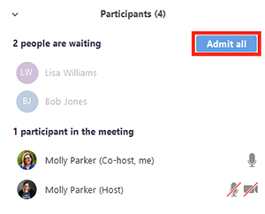

Polling for Class Evaluation Purposes

The polling feature for meetings allows you to create single choice or multiple choice polling questions for your meetings. You will be able to launch the poll during your meeting and gather the responses from your attendees. You also have the ability to download a report of polling after the meeting. Polls can also be conducted anonymously, if you do not wish to collect participant information with the poll results.

Note: Only the original meeting host can edit or add polls during a meeting. If the host or co-host role is transferred to another user, that user will only be able to launch polls already created.

Enabling Polling

For your own meetings

To enable Polling for your own use:
- Sign in to the Zoom web portal.
- Click Account Management > Settings (if you are an account member).
- Navigate to the Polling option on the Meeting tab and verify that the setting is enabled.
If the setting is disabled, click the toggle to enable it. If a verification dialog displays, choose Turn On to verify the change.
Note: If the option is grayed out, it has been locked at either the Group or Account level, and you will need to contact your Zoom administrator.

Creating a Poll
- Go to the Meetings page and click on your scheduled meeting. If you do not have a scheduled meeting, Schedule a meeting now.
- From the meeting management page, scroll to the bottom to find the Poll option. Click Add to begin creating the poll.
- Enter a title and your first question.
  - You can check the box to make the poll anonymous for the evaluations questions, which will keep the participant's polling information anonymous in the meeting and in the reports. The Poll for NRT distribution consent cannot be anonymous. This poll will be back up documentation for Florida Department of Health for NRT consent.
  - Select single choice for all questions.
- Type in the answers to your question and click Save at the bottom.
- If you would like to add a new question, click Add a Question to create a new question for that particular poll.

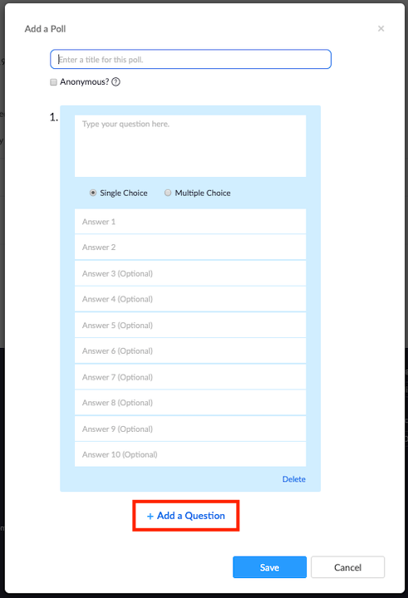
- You can add more polls by repeating Step 2.

You can also create a poll by clicking Polling during the meeting. This will open up your default web browser where you can add additional polls or questions.

Note: You can only create a max of 25 polls for a single meeting.

Launching a Poll
- Start the scheduled Zoom meeting that has polling enabled.
- Select the Polling option in the menu bar.
- Select the poll you would like to launch.
- Click Launch Poll.
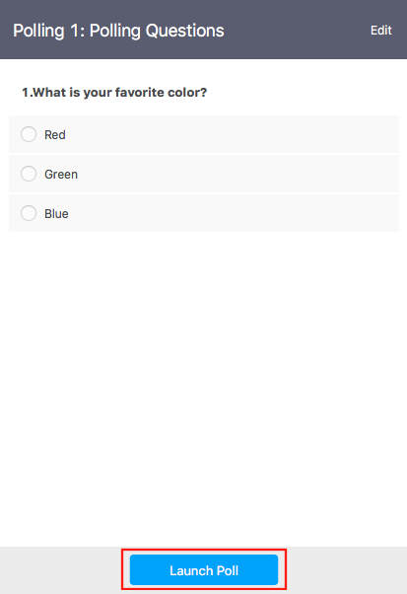
- The participants in the meeting will now be prompted to answer the polling questions. The host will be able to see the results live.
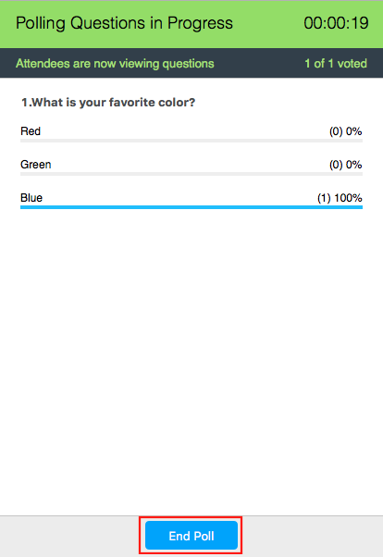
- Once you would like to stop the poll, click End Poll.
- Participants will then see the results of the polling questions.

Polling Questions

There are 2 polls required by the AHEC Cessation Program. Please see polls below which should be entered into the scheduled meeting before the start of the meeting.

Poll 1: NRT Distribution (Required for reporting)
- I am aware of the safe and appropriate use of NRT products. I understand that when using NRT products, I should follow the directions as listed on the product packaging. (Single Choice)

Answer 1: Yes

Answer 2: No
- I declare that I have no medical conditions prohibiting the use of NRT. (Single Choice)

Answer 1: Yes

Answer 2: No

Poll 2: Group Course Evaluation (Optional)

1. This class has improved my understanding of the benefits of quitting smoking/tobacco (Single Choice)
Answer 1: Very Much
Answer 2: Somewhat
Answer 3: A little
Answer 4: Not at all
Answer 5: Don't know

2. How interested are you in remaining tobacco free? (Single Choice)
Answer 1: Very interested
Answer 2: Interested
Answer 3: Somewhat interested
Answer 4: Not interested
Answer 5: Don't know

3. After this program, my motivation/desire to quit tobacco has: (Single Choice)
Answer 1: Decreased
Answer 2: Increased a little
Answer 3: Increased some
Answer 4: Increased a lot
Answer 5: Don't know

4. I am now able to visualize myself as a NON-smoker (tobacco free). (Single Choice)
Answer 1: Strongly agree
Answer 2: Agree
Answer 3: Somewhat Agree
Answer 4: Disagree
Answer 5: Don't know

5. Did we provide you with the tools needed to become and stay tobacco free? (Single Choice)
Answer 1: Yes definitely
Answer 2: Yes somewhat
Answer 3: Yes, a little
Answer 4: Not at all
Answer 5: Don't know

6. During the Tobacco Free Florida program, did the facilitator(s) allow enough time during activities to participate and voice questions and/or concerns? (Single Choice)
Answer 1: Strongly agree
Answer 2: Agree
Answer 3: Somewhat agree
Answer 4: Disagree
Answer 5: Don't know

7. How helpful was your facilitator(s)? (Single Choice)
Answer 1: Very helpful
Answer 2: Somewhat helpful
Answer 3: A little helpful
Answer 4: Not helpful
Answer 5: Don't know

8. The virtual cessation class was easy to join. (Single Choice)
Answer 1: Strongly agree
Answer 2: Agree
Answer 3: Somewhat agree
Answer 4: Disagrees
Answer 5: Don't know

9. The ZOOM platform was easy to navigate. (Single Choice)
Answer 1: Strongly agree
Answer 2: Agree
Answer 3: Somewhat agree
Answer 4: Disagree
Answer 5: Don't know

10. I would recommend the virtual cessation class to a friend or family member. (Single Choice)
Answer 1: Yes definitely
Answer 2: Yes somewhat
Answer 3: Yes a little
Answer 4: Not at all
Answer 5: Don't know

Ending the meeting
End Meeting (only available to the host): This will end the meeting for all participants. If you want to have the meeting continue, you should give another participant host control before leaving the meeting.

Generating Meeting Reports for Registration

With Registration enabled when scheduling a zoom virtual class, you can generate a registration report for further analysis. This will be GNAHEC “attendance sheet” for virtual classes.

The registration report contains the following information of registered participants:
- First and last name
- Email address
- Date and time of registration
- Approval status

Note:
- Meeting reports are automatically deleted 30 days after the scheduled date. This is also when the meeting is removed the from the Previous Meetings page in the web portal.
- If you delete a meeting from your Meetings list in the web portal, you cannot generate reports for that meeting. You can still download any reports you generated before deleting the meeting.
- You should generate meeting reports after your meeting has ended. If generated a report before starting the meeting, you should re-generate the report to obtain the data collected during the meeting.

Instructions
- Sign in to the Zoom web portal.
- Navigate to Account Management > Reports.
- In the Usage Reports tab, click Meeting.
A list of upcoming and previous meetings will be generated. You can search by time range or by meeting ID.
- Next to Report Type, select the Registration Report or Poll Report.
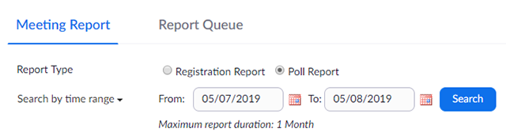
- In the drop-down menu below Report Type, select one of these options:
  - Search by time range: Select a time range then click Search.
  - Search by meeting ID: Enter the meeting ID and click Search.
- Click Generate in the last column. You can also use the check boxes to select multiple meeting then click Generate at the top.
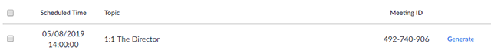
Zoom will redirect you to the Report Queues tab where you can download the report as a CSV file.
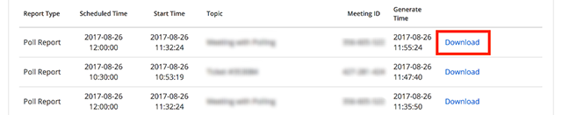

Virtual Classroom Set Up for Facilitators
- A laptop or desktop is preferred for hosting a Zoom class.
- Device camera or external web cam is needed for Zoom class.
- Be sure there are no visible personal items in screen view
- You can add a profile picture to your zoom account
- A microphone or USB headset with a microphone. (A headset with microphone provides the best quality sound.)
- Only approved curricula can be used on Virtual classes. Electronic versions of TTQ, QSN or Journey’s will be used to share virtually with participants through the host shared screen.
- Host Facilitator and Co-Host need to be the zoom meeting 15 minutes before the meeting starts.
- Host and Co-Host responsibilities: Before the Virtual Class the Host and Co-host should divide responsibilities.
- Facilitators can use the hardcopy curricula and NRT samples for visuals during the Virtual Meetings.

Adding a Profile Picture to ZOOM Account

Login to Zoom

Click on “Profile”

Next to your Name will be a box to add your profile picture.

Click “Change”

Click “Upload” to dd the picture from your files. Adjust the picture.

Click “Save”

This picture will now be your profile picture. If you turn your video off during a ZOOM meeting, this selected picture will show.

